A000-EUR-Greece-Standing Woman-Archaic-5th Cent BCE

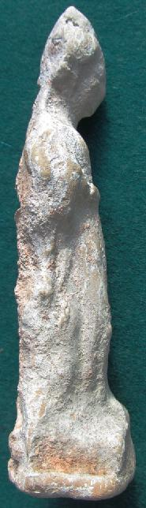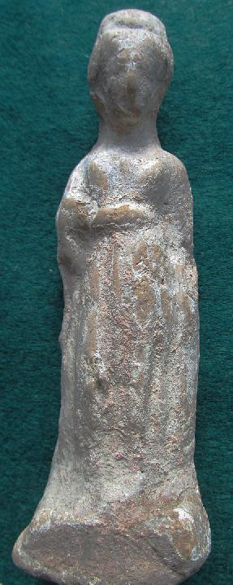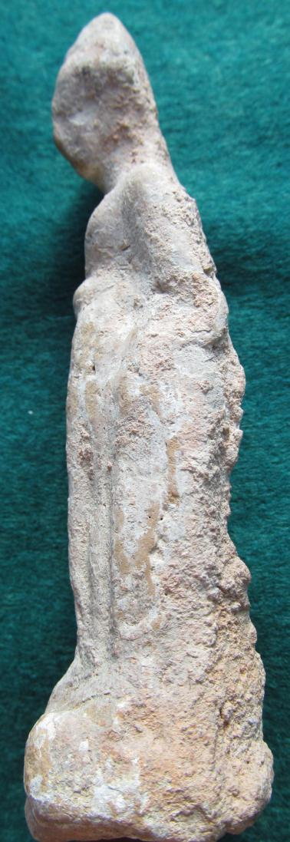

Greek Attic Terracotta, Standing Woman, with Himation, Chiton, Late Archaic, early 5th cent. BCE

Case No.: 4